Due Diligence process

Assume we have opportunity in Pipeline status and Type New Business
Assume we also have the opportunity readiness questionnaire filled
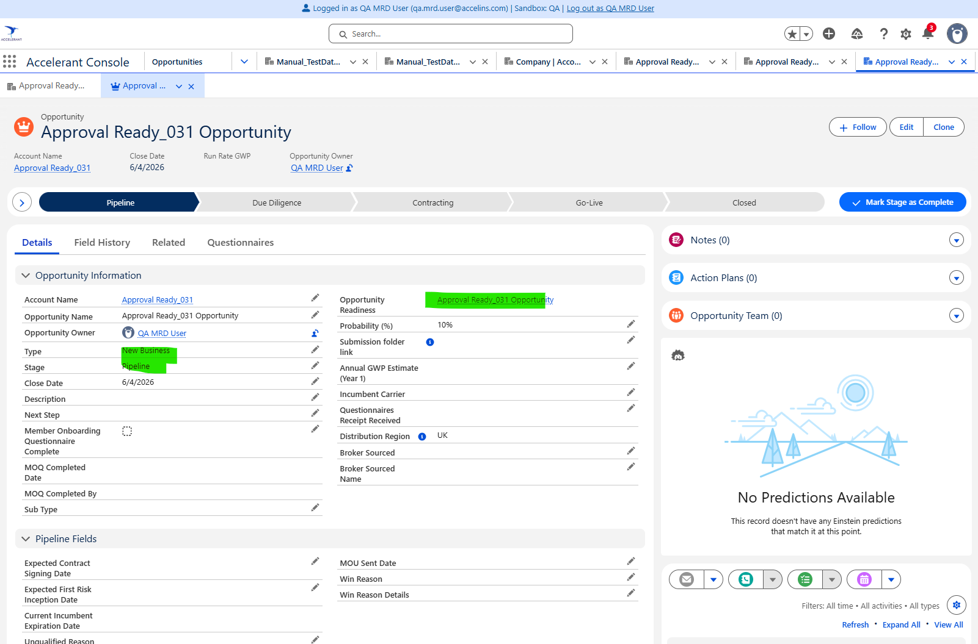
Step 1. Make sure all fields are filled in questionnaire and Submit the questionnaire
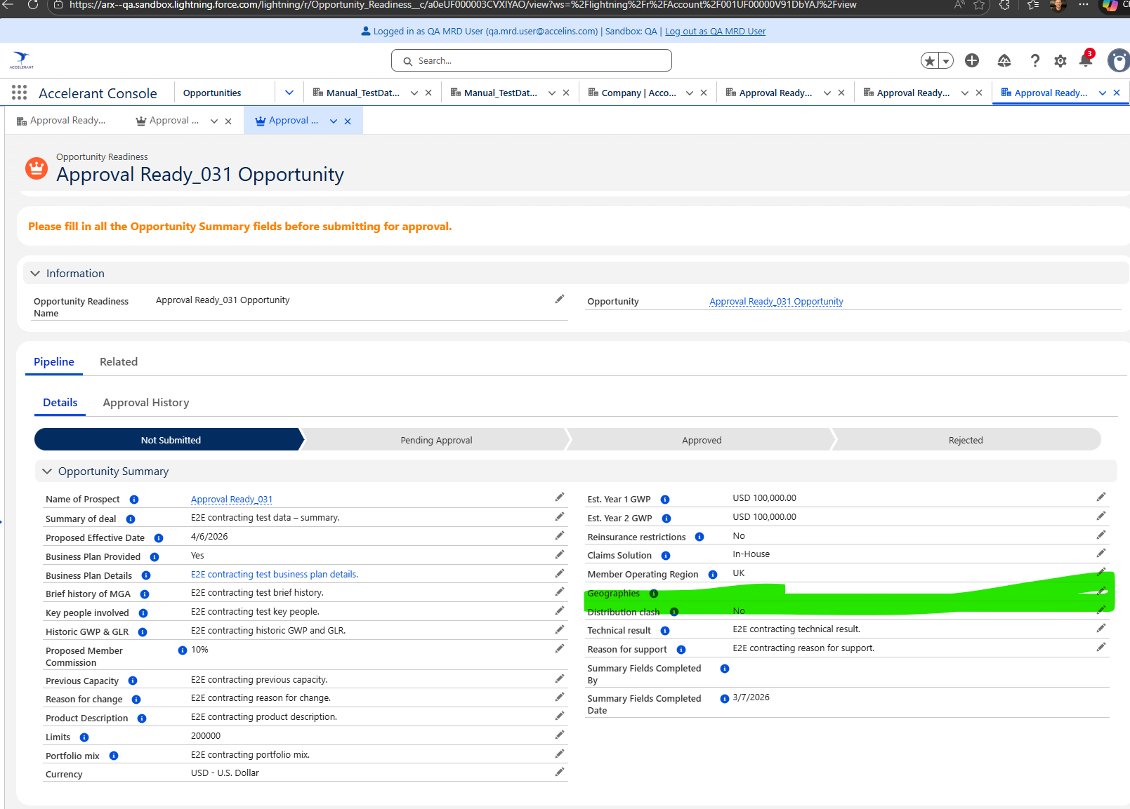
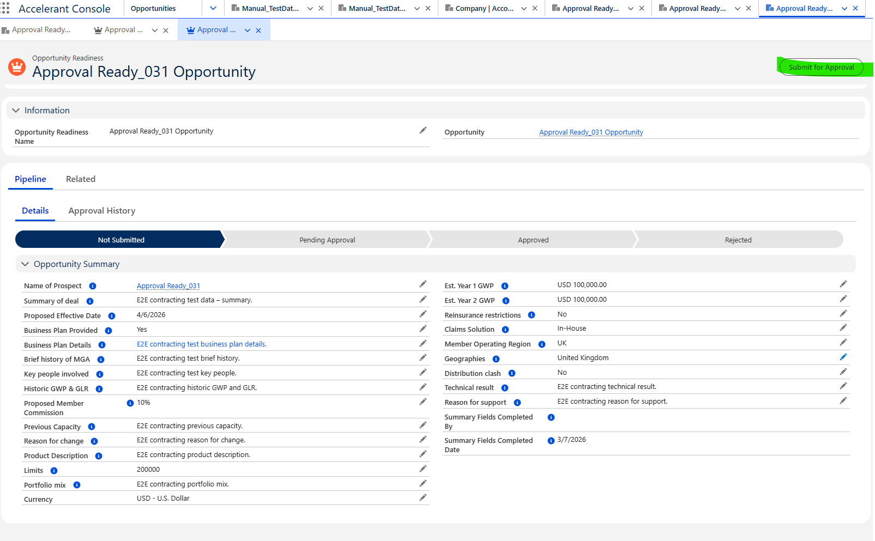
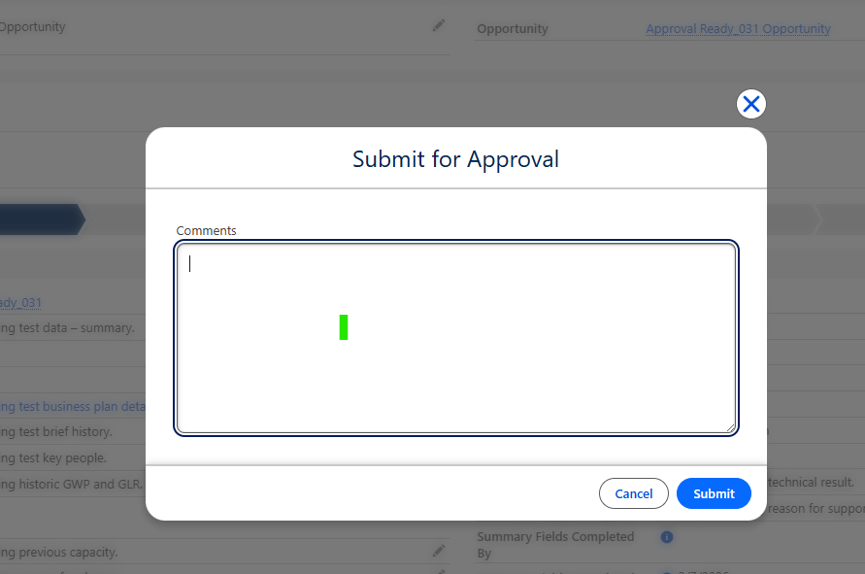

Step 2: Check the approvers and login as each approver and approve the questionnaire
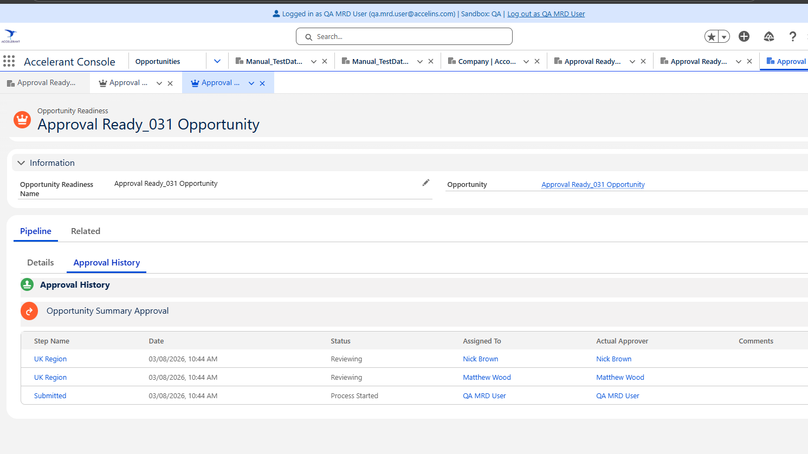

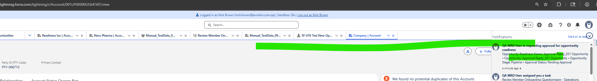
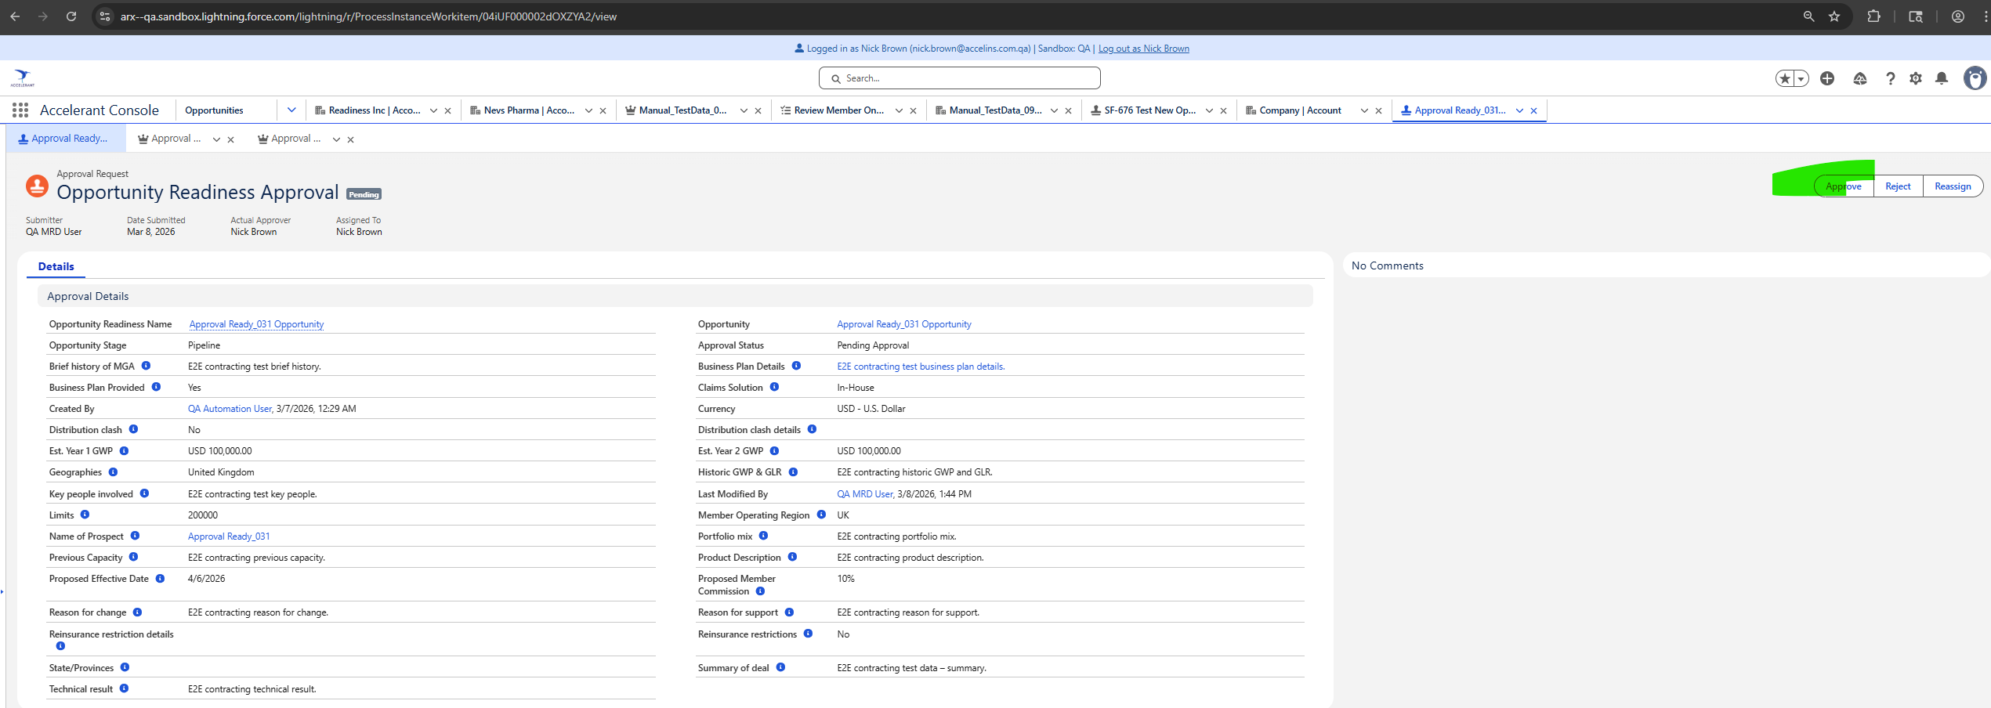

Step 3: After all approvers approve (For US only one approver needs to approve) – the Opporunity readiness becomes “Aproved Status”
Step 4: assign opportunity team 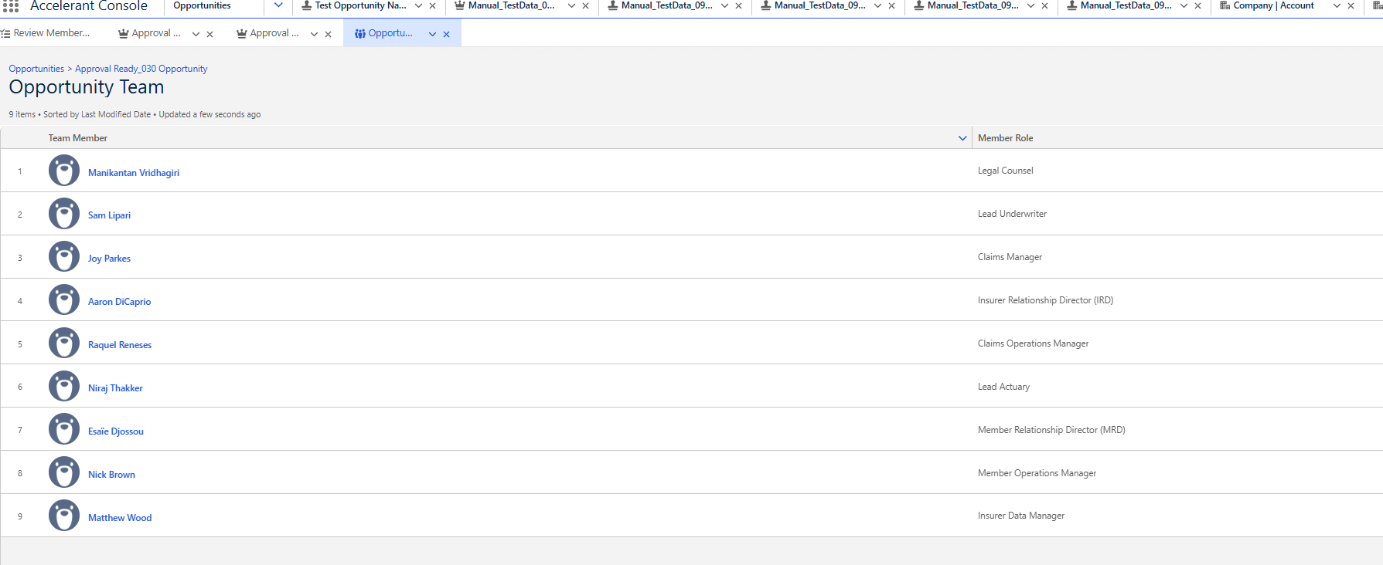

Step 5: Mark Questionaires Receipt received = Yes 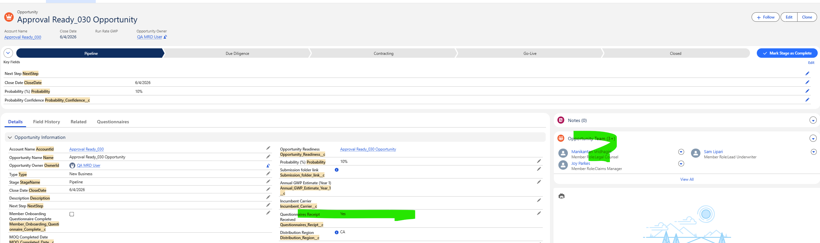
Step 6. This is a automated process which creates tasks for each of the opportunity team member from previous steps 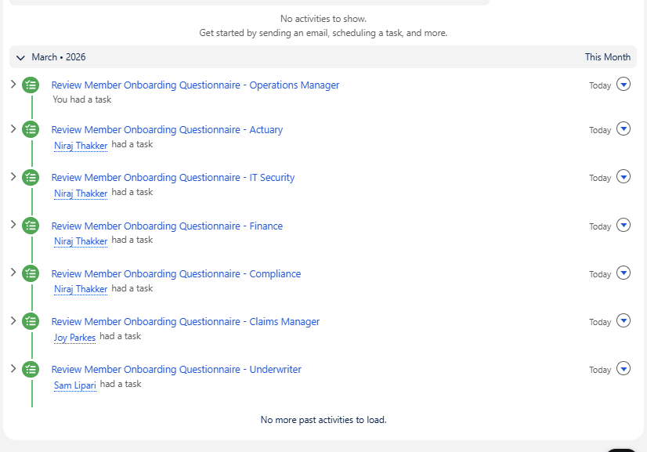
Step 7: Login as each ofthose approvers and complete the due diligence section and mark the task as Complete 